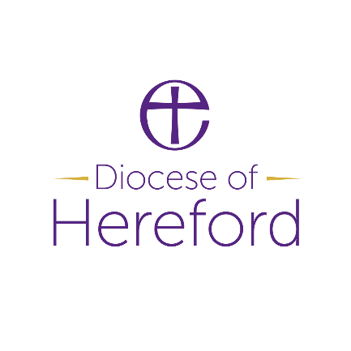
Job Description:
Area Co-ordinator
Job Purpose:
To oversee and co-ordinate administration in the Area, as agreed with local parishes. Supporting the work of the Rural Church Missioner

Accountabilities:
Working with the Rural Church Missioner and their team as well as incumbents and PCCs in the Area, as required in relation to the RCM role.
Primary responsibilities:
- Offer administrative support to the Rural Church Missioner, working closely with local churches with their agreement
- Support the development of plans for churches and keep records of the status of all smaller rural churches in the area
- Where needed, ensure systems are in place for basic administration such as rotas, bookings, records, this may include bookings for special events
- Oversee other routine administration such as church building maintenance, finance plans and safeguarding/safer recruitment compliance/grant applications for churches that are being worked with
- Help develop and keep updated websites, social media etc, for missional projects as needed, as well as advertising special events and projects. i.e development of pilgrimage trail.
- Administration for special projects such as pilgrimage trail may include liaising with community businesses/collating information
- To attend meetings of local missional projects and provide administrative support
Other responsibilities include:
- Maintain and review digital and paper information systems in line with GPDR
- Routine administration in support of the Rural Church Missioner (includes sending/receiving emails; formatting/editing/printing papers/memos/reports/documents; arranging meetings)
- Ensure relevant statistics and records are accurate and prompt
- Undertake such other tasks as may be reasonably requested by the Line Manager and meet regularly with the Line Manager
Key working relationships:
- Rural Church Missioner
- Area Rural Deans
- Incumbents and PCCs
- Existing and potential lay and ordained ministers in the Area

Organisation Chart

Area Co-ordinator
Rural Church Missioner

Qualifications & Experience
AREA | ESSENTIAL | DESIRABLE
Knowledge/ Qualifications/ Membership of Professional bodies (or equivalent) | Intermediate level in Microsoft Office (or equivalent software) | GCSE English Language (or equivalent)  Advanced Level in Microsoft Word  Knowledge of church administrative systems
Type of Experience required | Excellent working and up to date, knowledge of Microsoft office using Word, Excel PowerPoint, Publisher and Office 365.  Used to working to tight deadlines, able to take messages, prioritising tasks and maintaining filing systems and confidential records.  Experience of being able to work on own initiative.  Excellent interpersonal and communication skills: outgoing, friendly and adaptable with a warm telephone manner.  Experience of co-ordinating people and arranging events and rotas | Experience of dealing with telephone enquiries  Extensive experience in use of Microsoft Office  Knowledge of social media  Experience of updating webpages  Experience of working in a church setting  Experience of using The Church Organiser / Life Events Diary  Experience of dealing with financial administration
Competencies
ESSENTIAL | DESIRABLE
Sympathetic to working with people of faith and the ethos of the Church of England.
Access to own transport when travel is required.
Willing to occasionally work flexibly as required.
A team player who can work well collaboratively.
Able to demonstrate high levels of accuracy and attention to detail.
Discreet and able to deal with confidential matters.
Able to co-ordinate between various parties and make arrangements for events.

